Experiment-2

Aim: To write a python code to implement Depth first search.

Procedure:

1. **Start at the root node** (or any chosen starting node).
2. **Use a stack** (LIFO) to keep track of nodes to visit.
3. **Mark the current node as visited** (to avoid cycles/revisits).
4. **Process the node** (e.g., print its value).
5. **Push all adjacent/unvisited nodes** into the stack.
6. **Repeat** until the stack is empty.

Code with output:

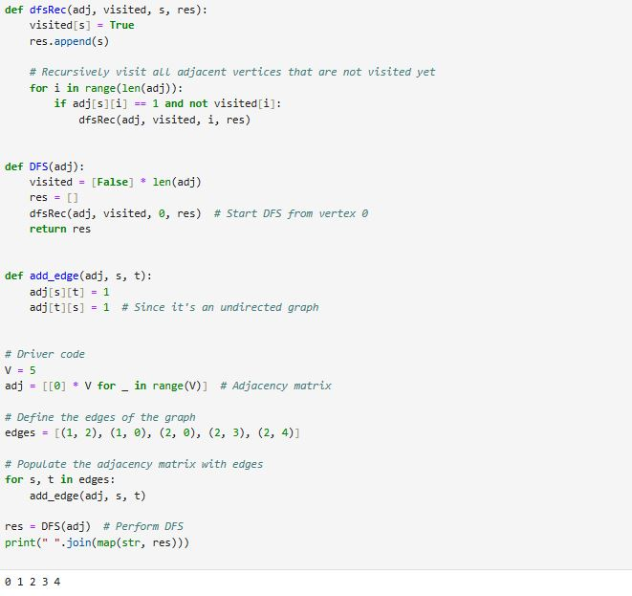

Result: The code for Depth first search is compiled and studied successfully.